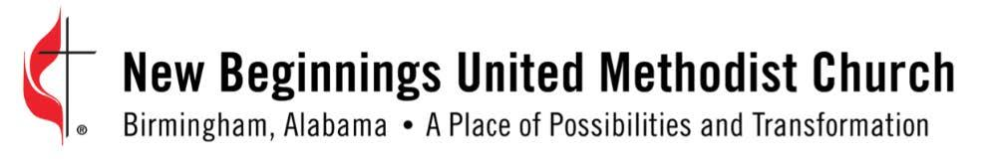
Church-wide Announcement Worksheet
Due the Tuesday prior to the first Sunday.
Announcement Title: Click or tap here to enter text.
Post Announcement Date: Click or tap here to enter text. Ministry Team: Click or tap here to enter text.
Contact Person: Click or tap here to enter text.
Phone/Email: Click or tap here to enter text.
Type: ☐ Event/Meeting ☐ Program ☐ Printed Material ☐ Web Content ☐ Calling Blast ☐ Email Blast
Ministry Area: ☐ Discipleship ☐ External Fellowship ☐ Missions ☐ Worship ☐ Music ☐ Administrative
☐ Other: Click or tap here to enter text.
Date:Click or tap to enter a date. Set Up Time: Click or tap here to enter text.Start Time: Click or tap here to enter text. End TimeClick or tap here to enter text.
Location: Click or tap here to enter text.
Promotional material has been previewed (graphic, event announcement, flyer) ☐ No expected ☐ Yes on _________
Many events are planned and advertised with little results in reaching new attendees. We are hoping that this form will assist you in thinking of creative ways to highlight your event by answering the questions below.
How does this fit into the church’s mission/vision/S.M.A.R.T. Goals?
Click or tap here to enter text.
What will people miss if don’t attend? (promoting the event is an important step for getting people interested in attending)

What is interesting about the event or is unique that would spark interest for people to attend?

Submitted to Regina Warren on __________ By ____________________________________________________________
Church Marquee Message:____________________________________________________________________________
___________________________________________________________________________________________________
Received by Media Coordinator or Media Team Member: on ______________
Name of Media Team Member__________________________________________________________________________
Assigned to: ________________________________________________________________________________________

Email this form to Media – Click on email link: media@newbeginningsbham.org

